By Henry Samuel, Paris

6:56PM GMT 29 Oct 2015

Three quarters of cars stolen in [France](http://www.telegraph.co.uk/news/worldnews/europe/france/) are targeted using electronic hacking, it was claimed on Thursday, prompting calls for urgent security improvements in a range of vehicles sold across Europe.

The Smart Fortwo model was France’s most-stolen car, with the Ford Fiesta and Peugeot 406 models also popular among thieves who it is feared could use the same hacking methods in Britain.

The astonishing figures come [two months after computer scientists in the UK warned](http://www.telegraph.co.uk/news/uknews/11808814/Thousands-of-cars-vulnerable-to-keyless-theft-according-to-researchers.html) that thousands of cars – including high-end brands such as Porsches and Maseratis - are at risk of electronic hacking. Their research was suppressed for two years by a court injunction for fear it would [help thieves steal vehicles to order](http://www.telegraph.co.uk/technology/10205983/Academic-banned-from-publishing-Porsche-security-codes.html).

The kit required to carry out such “mouse jacking”, as the French have coined the practice, can be freely purchased on the internet for around £700 and the theft of a range of models can be pulled off “within minutes,” motor experts warn.

The figures have prompted urgent calls by a top French car consumer magazine for manufacturers to “secure your cars”.

Many cars use radio frequency identification chips which are designed to verify the identity of the ignition key being used to start the car engine. If thieves get into the vehicle without the right key, the engine should refuse to start.

However, it is possible electronically to listen to signals sent between the security system and the key fob via a computer programme to analyse and emulate it. Once this is done, it is possible to unmask the vehicle’s secret code very quickly and start the engine.

According to Traqueur, French leader in detecting and recovering stolen cars, some 74 per cent of the cars stolen in the first four months of this year were swiped electronically.

On Thursday, French car magazine 40 Millions d’automobilistes (40 Million Motorists) published a [hit parade of the country’s most stolen cars](http://www.40millionsdautomobilistes.com/sites/default/files/20151029barometreauto.pdf) from among the 110,000 taken last year.

The Smart Fortwo model came top, accounting for almost 12 per cent of the total. Ford Fiesta was second on almost 11 per cent and Peugeot 406 third on almost six per cent. Almost all the models in the top ten were French or German-made.

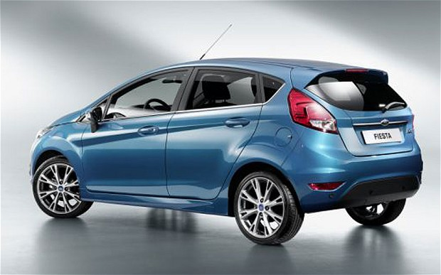The Ford Fiesta model came second accounting for almost 11 per cent of the total stolen cars

Besides ease of theft, these are targeted due to the flourishing black market for their spare parts.

Pierre Chasseray, head of 40 Million Motorists, singled out Smart cars saying “you only need to lift up a plastic panel to hack this vehicle.

“We already underlined this weakness last year. Smart has got to do more to secure their cars.”

But he told Le Parisien newspaper that all carmakers were in “urgent” need of improving electronic security. “Almost the entire car fleet in France can be hacked like a computer today. A car thief today is a technician without needing to be a computer genius. He just needs to connect his little electronic box to open the car”.

“It is a matter of urgency as electronic theft is now massive. I am calling on makers: secure your cars,” he said.

A brief internet search is all it takes to find the required material. According to Le Parisien, it costs only €70 (£50) to purchase a “mechanical universal key” whose sellers claim enables thieves to break into a Porsche, Audi, Vokswagen, Seat or Skoda undetected. The listening device to crack the immobiliser reportedly costs around €1,000.

In August, researchers at Birmingham University and Radbound University in Nijmegen, the Netherlands, revealed they were able to intercept signals sent between the chip and the car.

The researchers highlighted a weakness in the Megamos Crypto system, a piece of technology used by big manufacturers such as Audi, Fiat, Honda, Volvo and Volkswagen.

They identified the flaw in 2012 after UK police said they were baffled by rising numbers of “keyless car theft”. The Metropolitan Police says some 6000 vehicles were stolen without keys last year – almost half of all thefts.

However, Volkswagen won a High Court injunction preventing its publication on the grounds the information could be used by criminal gangs.

A spokesman for Volkswagen said: “In all aspects of vehicle security, we go to great lengths to ensure the security and integrity of our products against external malicious attack.”

Pierre Steward of Experveo, which helped analyse the French theft figures, said: "Car makers have made improvements in their latest models, but given the number of electronic thefts, either they're not doing enough or the criminals are clearly one step ahead. If I was cynical I would say that for manufactuers, one car stolen is another car for sale."