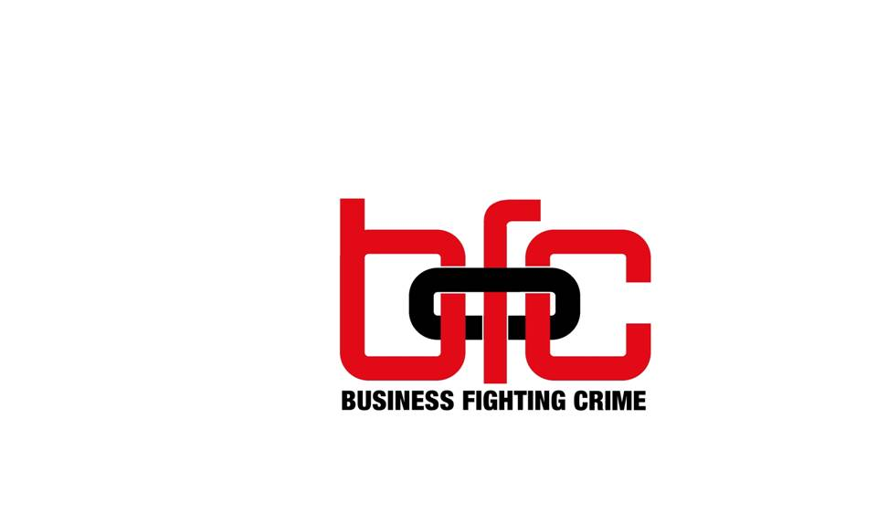

CHAIRPERSON’S REPORT
25 JULY 2019

BFC CHAIRPERSON’S REPORT 2018 - 2019

2018/2019 has been a very eventful year for Business Fighting Crime.
Due to the various caps I wear representing other organisations, namely MEDA(Msunduzi Economic Development Agency), being the businesses downtown, this has resulted in various overlaps that also suit the interests of Business Fighting Crime. I have therefore in this regard also included PCB when matters of this nature have arisen. To elaborate, during the latter part of 2018 we had written a memorandum to the Mayor in respect of various issues plaguing the Capital of the Province. This then catapulted into PCB, MEDA and I meeting with the then MEC for economic development, Mr. Sihle Zikalala and members of council where we voiced our concerns for the City. We were advised that a plan of action would be put in place by early 2019. Subsequently a meeting with President Cyril Ramaphosa ensued where he was also filled in on the issues that were raised in the memo.
The MEC then requested to meet all businesses in April 2019, where he apologised for the state of Pietermaritzburg and for having failed in his efforts to get our municipality in order and to come up with the plan of action as was previously advised. He informed us that upon his instruction Msunduzi will now be under administration. At this meeting he requested that a task team be formed with business (PCB & MEDA), KZN Trade and Investment and other relevant stakeholders. This task team subsequently met and we call ourselves the Msunduzi Economic Intervention Task Team. The task team has also done visits at various hotspots plaguing PMB. We are currently preparing a report for the now Premier of KZN Mr Sihle Zikalala, in respect of our findings.
We have also met with the Administrator Mr. Sithole recently to bring him up to speed with regards to the aforementioned. It was resolved at this meeting that council should not work in silos to plan for the city without consultation with business and other relevant stakeholders that have a vested interest in the City. It was agreed that a task team comprising of business, council and other relevant stakeholders be formed for there to be progress for Msunduzi. We are now awaiting Mr. Sithole’s confirmation on when this task team will be meeting.
I mention all of this because whilst Business Fighting Crime’s purpose is in respect of crime related issues, one cannot ignore that the other issues plaguing PMB viz traffic, grime, poor service delivery, poor infrastructure are all intertwined in the fight against crime. We are hopeful that in spite of the various hurdles our municipality is facing that progress is at the end of the tunnel.
In March 2019, Speedy Locksmiths lived up to its name by coming to the rescue of the Midlands ID Parade room that had its lock broken and repairing it at no cost. Built in the 1990s by Business Against Crime, the forerunner of Business Fighting Crime (BFC), the Midlands ID Parade room at the Hilton SAPS offices allows witnesses to safely and legally identify perpetrators. In 2017/8, BFC, upgraded the cameras and recording equipment. Still the only ID facility in the region, the facility supplies usage statistics on a bi-monthly basis to BFC.
Whilst I acknowledge that Mandela day should be every day, not all of us are able to do this and some are not able to do it even on Mandela Day itself. BFC through kind sponsorship have however tried in our small way to make a contribution to this day. A project, which was in partnership with SAPS and the Pietermaritzburg Community Policing Forum (CPF), saw us give the little one’s at the Jika Joe Crèche Mc Donald’s happy meals and goodie bags. (See pictures attached). I can assure you that what most of us take for granted was a delicacy to those little’s ones that I had the pleasure of engaging with.
BFC have also sponsored meals for the Youth month project. Due to the school holidays this project could only take place on July 23rd. The project comprised of a partnership with BFC, The Pietermaritzburg Community Policing Forum (CPF), SAPS, the Department of Correctional Services and a few other relevant stakeholders. We wanted to educate our youth on the effect of crime and its consequences; hence we took the youth from a certain high school in the City as well as children living on the streets for a tour of the New Prison, in Napierville. The youth also had dialogue with juvenile prisoners to make them more conscious of their future and their conduct. (See pictures attached) Let us pray that we achieve our purpose and objective in this regard.
I don’t have much feedback for you in respect of the recycling project that I mentioned last year except to say that Melanie and I are trying to make some headway on this and are currently working on aspects of how we can put all the pieces of this puzzle together.
The year that has passed has been challenging as I have found it difficult to get people to come to meetings and in light of this BFC have now changed our meeting time to 14h30 to accommodate individuals and departments that were not attending in the past but whose input is quite valuable.
You will also shortly see us feature in the E-Blitz regularly directing you to our website where you may report crime related matters to our partner in crime (excuse the pun) Safe City. We are hoping to have more crime tips uploaded on our webpage and with constant pressure that I am putting on SAPS to submit same to us, I am confident that we will have this on more continuous basis in future.

BFC’s current financial position sees us with a deficit of R24, 796, which is much better in comparison to 2017. The events that we sponsored do not reflect here as the financials are as at the end of last year. This sponsorship will therefore reflect in the financials for the next AGM. We are most thankful to all our sponsors that we continue to receive contributions from as well as others who have sponsored for specific projects. Without your support we will not be able to do what we do. We have for the year ending 2018, received donations totalling R 9,000,00 which is much less than what we received last year. We are of the view that sponsorship will come if they are project related; hence we are aiming to do much more projects in the future. We must however ensure that our operating expenses are paid for, and these donations therefore also contribute to the payment of same. The detail of this can be found in the financials.
I thank Moore Stephens RB Incorporated, for preparing the annual financials and for ensuring that BFC is always transparent in respect of same.
To the staff of PCB, I wish to say thank you for your continued support, in more ways than one, it is most appreciated, especially when one wants to throw in the towel.
Finally, to the BFC committee I thank you for everything, in particular Geraldine Botha for being our industrious fund raiser and who was instrumental in getting the sponsorships for the aforementioned projects.

I must also make a humble appeal that we stay committed to assist, in the fight against crime, wherever we can. Let us not leave it to one individual but rather stand together as a team. I do believe that there is strength in numbers and together we can achieve a safer PMB!!!

Kantha Naidoo
BFC Chairperson

REPAIRS TO THE MIDLANDS ID PARADE ROOM LOCK – MARCH 2019
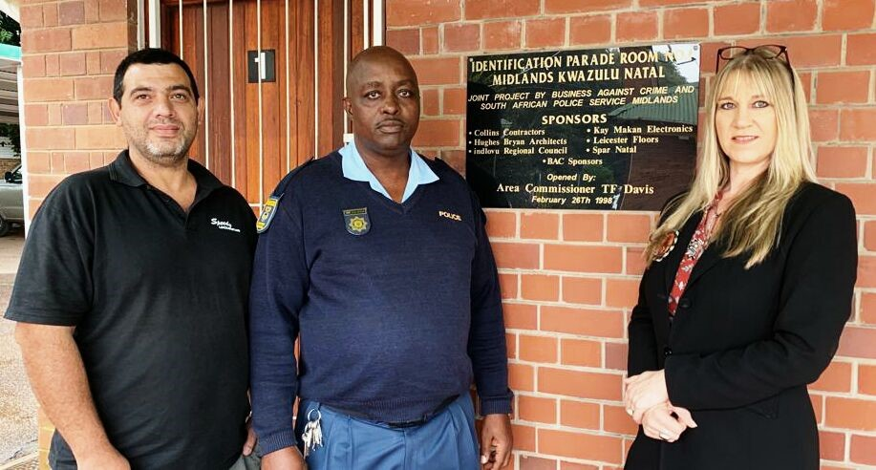
(ltr) Ernest van der Zandt (Speedy Locksmiths); W/O LF Zitha (acting station commander) and
PCB CEO Melanie Veness.

JIKA JOE CRECHE – BFC 18 JULY 2018
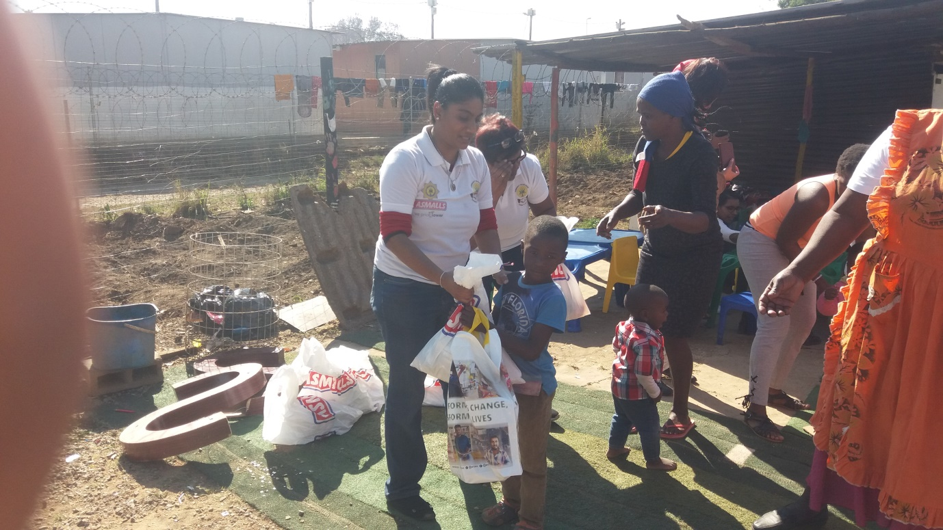

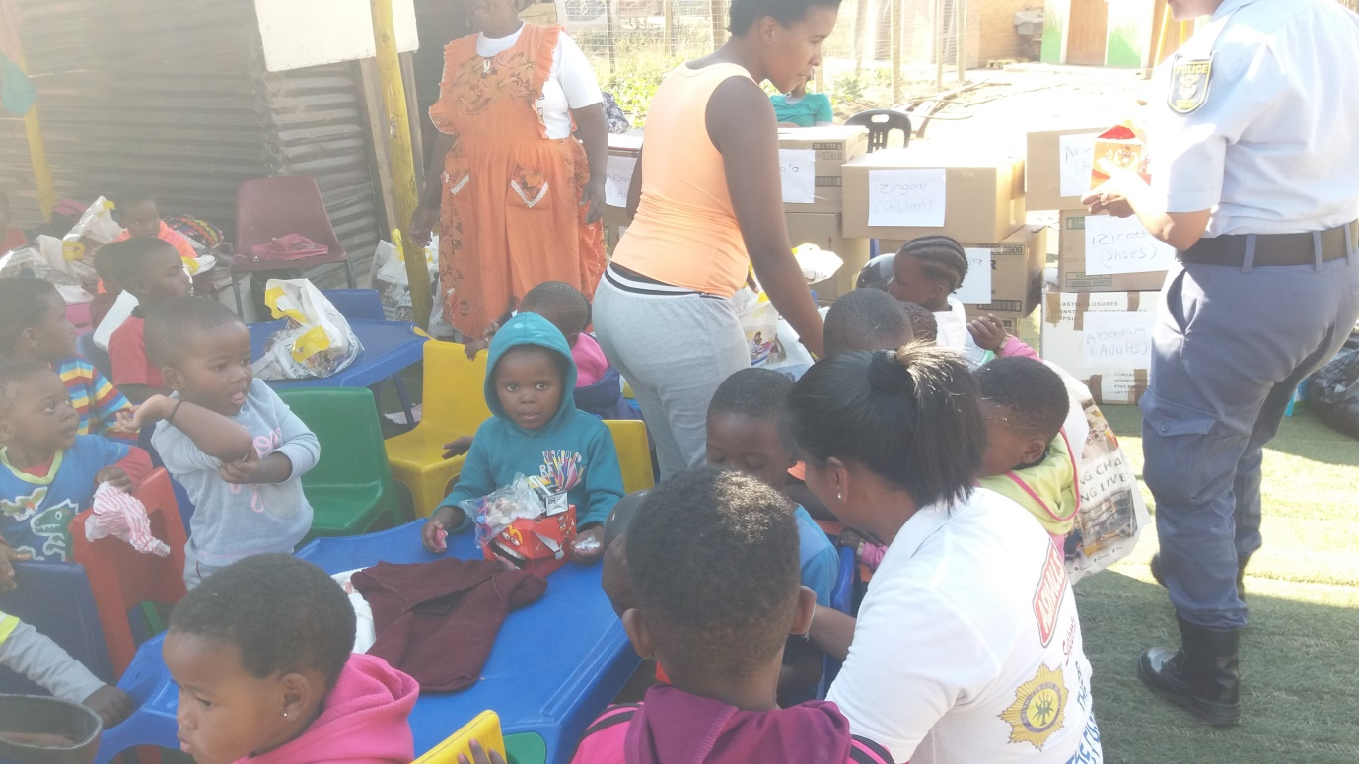

LEARNERS BEFORE– JUVENILE PRISON TOUR 23 JULY 2019
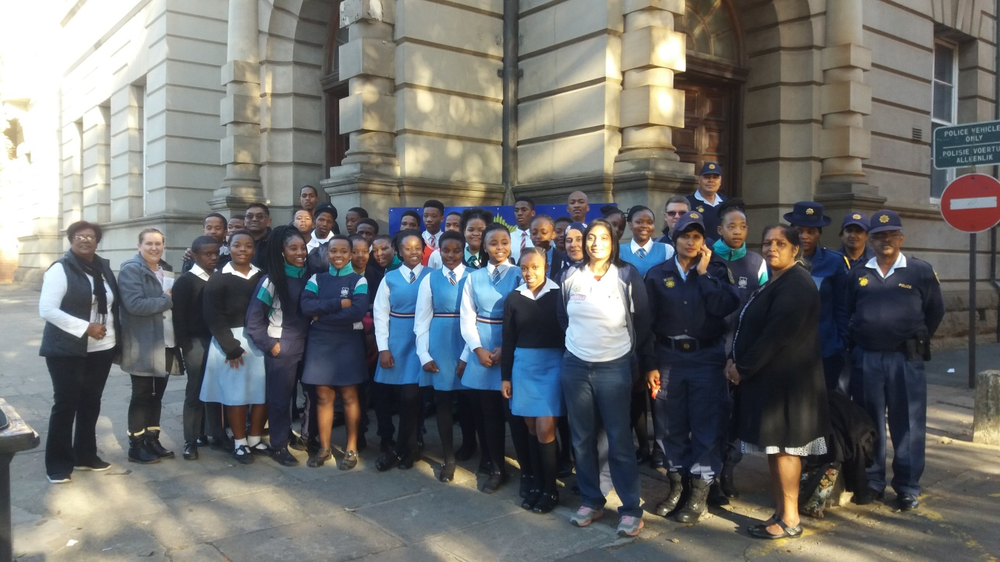
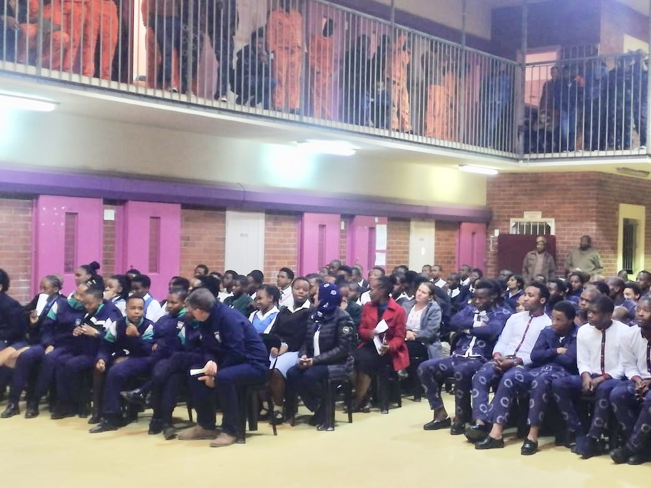
LEARNERS AT THE JUVENILE PRISON - 23 JULY 2019

JUVENILE PRISON TOUR 23 JULY 2019
